**Nama : Fansyah Dwi krisnady**

**Kelas : TI 1 Semester 3**

**Nrp : 14519077**

**Materi : Struktur Data**

**Urutkan array dibawah ini dengan algoritma bubble sort dengan pengurutan descending**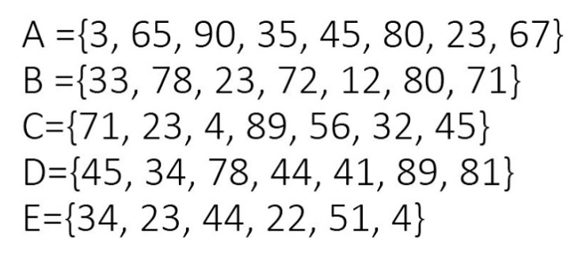

Jawab:

1. Data Awal : 3, 65, 90, 35, 45, 80, 23, 67

|  |  |  |  |  |  |  |  |  |
| --- | --- | --- | --- | --- | --- | --- | --- | --- |
| Tahap 1 | 65 | 90 | 35 | 45 | 80 | 23 | 67 | 3 |
| Tahap 2 | 90 | 65 | 45 | 80 | 35 | 67 | 23 | 3 |
| Tahap 3 | 90 | 65 | 80 | 45 | 67 | 35 | 23 | 3 |
| Tahap 4 | 90 | 80 | 65 | 67 | 45 | 35 | 23 | 3 |
| Tahap Akhir | 90 | 80 | 67 | 65 | 45 | 35 | 23 | 3 |

1. Data awal : 33, 78, 23, 72, 12, 80, 71

|  |  |  |  |  |  |  |  |
| --- | --- | --- | --- | --- | --- | --- | --- |
| Tahap 1 | 78 | 33 | 72 | 23 | 80 | 71 | 12 |
| Tahap 2 | 78 | 72 | 33 | 80 | 71 | 23 | 12 |
| Tahap 3 | 78 | 72 | 80 | 71 | 33 | 23 | 12 |
| Tahap 4 | 78 | 80 | 72 | 71 | 33 | 23 | 12 |
| Tahap akhir | 80 | 78 | 72 | 71 | 33 | 23 | 12 |

1. Data Awal : 71, 23, 4, 89, 56, 32, 45

|  |  |  |  |  |  |  |  |
| --- | --- | --- | --- | --- | --- | --- | --- |
| Tahap 1 | 71 | 23 | 89 | 56 | 32 | 45 | 4 |
| Tahap 2 | 71 | 89 | 56 | 32 | 45 | 23 | 4 |
| Tahap Akhir | 89 | 71 | 56 | 45 | 32 | 23 | 4 |

1. Data Awal : 45, 34, 78, 44, 41, 89, 81

|  |  |  |  |  |  |  |  |
| --- | --- | --- | --- | --- | --- | --- | --- |
| Tahap 1 | 45 | 78 | 44 | 41 | 89 | 81 | 34 |
| Tahap 2 | 78 | 45 | 44 | 89 | 81 | 41 | 34 |
| Tahap 3 | 78 | 45 | 89 | 81 | 44 | 41 | 34 |
| Tahap 4 | 78 | 89 | 81 | 45 | 44 | 41 | 34 |
| Tahap akhir | 89 | 81 | 78 | 45 | 44 | 41 | 34 |

1. Data Awal : 34, 23, 44, 22, 51, 4

|  |  |  |  |  |  |  |
| --- | --- | --- | --- | --- | --- | --- |
| Tahap 1 | 34 | 44 | 23 | 51 | 22 | 4 |
| Tahap 2 | 44 | 34 | 51 | 23 | 22 | 4 |
| Tahap 3 | 44 | 51 | 34 | 23 | 22 | 4 |
| Tahap akhir | 51 | 44 | 34 | 23 | 22 | 4 |